Research Alumni

Class of 2018

Matthew Berman
Washington University in St. Louis

I entered WashU on the pre-med track, yet not entirely sure about intended majors and minors or fields of interest. Over the course of this year I have declared majors in Medical Anthropology and Cell and Molecular Biology; research played an instrumental role in developing both of these interests. I have also recently decided to minor in Design with a concentration in Fashion. On campus I am involved in a social and pre-professional, healthcare-oriented fraternity, peer-tutoring program, and the University’s Doctors Without Borders subsidiary. My biggest time commitment, however, is my volunteer work as a lab technician for a Neurology/Anesthesiology laboratory at Barnes Jewish hospital—the Moron-Concepcion Laboratory. I am presently assisting a PhD candidate in a study which focuses on the behavioral effects of opioids, including the neuronal mechanisms which underlie the effects of opioids and opioid dependence on synaptic plasticity. This coming summer I will be transitioning out of an oncologic immunology lab and into a tissue regeneration and stem cell-focused lab. In the coming years I hope to apply to a dual MD/MPH program and to continue researching.

Bailey Kaplan
Case Western Reserve University

Currently I am double majoring in computer science and cognitive science, with strong focuses in human computer interactions and user experience. Throughout the next few years, I am hoping to take my knowledge of these two areas and apply them to healthcare fields specifically including digital health and electronic medical records. On campus I am involved in a number of organizations, my favorites being WISER which is CWRU’s women in STEM club, SpartanTHON more commonly known as our school’s dance marathon chapter (I just got the executive board position of outreach director), and Design for America where I completed a mental-health awareness project. Additionally, I am the founder of a program on campus that goes into a local Cleveland school and teaches the elementary school students to code for about an hour each week. This summer I am interning at GE Transportation a Wabtec company (EDIT: for legal reasons I have to sat “a Wabtec company” since they were just divested- you can take this part out if you think it sounds weird lol) as part of their IT leadership and development program in their UX department.

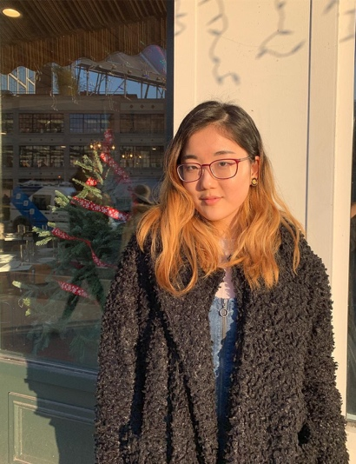
Class of 2017

Yena Kim
University of Chicago

I'm happily studying psychology at the University of Chicago. As the lab manager of the Attention, Perception, & EXperience (APEX) Lab, led by Dr. Howard Nusbaum, I run the lab website and conduct independent research on various topics: the relationship between wisdom and emotional intelligence; how psychological distancing influences problem-solving; and perceptions of speakers’ identities. Outside of the lab, I'm usually planning events as Behar House president, attending concerts, and exploring the city. I'm also the creative vice president of the marketing club (The Mark) and a former research assistant at the Booth School of Business (in Nick Epley's lab). This summer, I'll be interning as a user experience (UX) researcher at a local usability lab. Please reach out to me if you have any questions about social-cognitive psychology or UChicago or mentorship or life! (Contrary to my reputation in high school, I'm not as intimidating as you may think!!!)

Anuj Gupta
Columbia
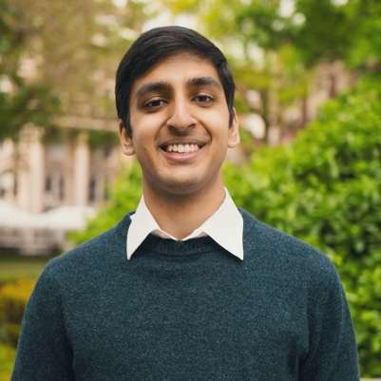
I’m a rising junior in Columbia College pursuing a major in Biology. I’m also pre-med, and would like to study oncology in the future. I do a lot of CRISPR-Cas9 research at Columbia, and last week our lab was informed that a paper I co-authored will be getting published in Nature Communications sometime this summer (would love to send you the link when it’s released!). Outside the classroom, I’m president of the Hindu students organization, a counselor for Camp Kesem (a summer camp for children whose parents have cancer), and a member of Columbia Raas (an indian dance team that travels and competes nationally).

Justin Leu
Stony Brook

I'm currently a member of Stony Brook's Scholars for Medicine combined undergraduate and medical school program. Inside of the classroom I am pursuing a degree in biochemistry and cancer biology. Outside of the classroom I am a state-certified EMT working as part of Stony Brook Volunteer Ambulance Corps and am currently pursuing research on the effect of aneuploidy on cancer at Cold Spring Harbor Laboratory.

Chloe Levin
Barnard
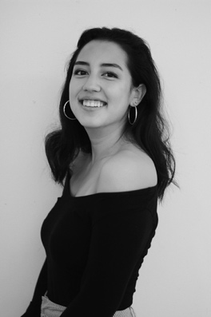
I am currently a rising Junior at Barnard College majoring in Psychology with a possible minor in Human Rights. On campus I am President of Columbia Taekwondo, the school’s leading competitive martial arts team, and write as a columnist for Barnard College’s first Psychology Journal. I also spend my Saturdays as a coordinator for Columbia Youth Adventurers, a mentorship program which provides low-income children with the opportunity to engage in learning excursions across NYC. In my spare time I assist with research studies at the Columbia Business School Behavioral Research Center, the most recent focusing on the role of gender in election results.

Jason Wu
University of Pennsylvania

At Penn, I am planning to major in Health and Societies and minor in Health Care Management. I am involved with several organizations such as GlobeMed, Wharton Undergraduate Healthcare Club, and the Daily Pennsylvanian. As a PURM student and a Hayden Fellow, I will be working in the Sallan Lab this summer. I will be studying the evolution of current biodiversity caused by periods of maximum glaciation (ice ages) and assist in assembling the first-ever database of fish biodiversity over the last 34 million years. In addition, I will also spend time volunteering at the Hospital of the University of Pennsylvania (HUP).

Class of 2016

Nicolas Furci
Emory

I have been studying Psychology and Philosophy and am planning on pursuing a double major. My academic interest is the application of mindfulness and philosophical principles in developing clinical interventions for depression. I am a member of the Mock Trial team and am competing at the Pre-National tournament this weekend. In the fall I was named an Outstanding Witness at the FSU Mock Trial Invitational with 17 ranks. I am also a new brother in the Alpha Tau Omega fraternity on campus. This summer I am working as a research assistant in a developmental psychology lab at the University of Santa Barbara. If anyone ever has any questions on developmental psychology, philosophy, or life feel free to contact me at nick.furci@emory.edu or npfurci@gmail.com.

Mahip Grewal
University of Pennsylvania

I am majoring in Biological Bases of Behavior (Neuroscience) and minoring in Healthcare Management. I’m involved in a number of organizations such as the South Asia Society, Synapse, which is an undergraduate healthcare journal, Penn Red Cross, and the UPenn Global Medical Brigade. I have joined the Brodkin Lab, which studies autism, in the Translational Research Laboratory of UPenn. I will be starting research this summer; I will be working on a human genetics study of austin spectrum disorder/Aspergers disorder focused on the role of the Neurexin1 gene. Essentially, I’ll be assisting with recruitment, phenotyping, and genetic analysis of patients with Aspergers and their extended families.

Class of 2015

David Jaslow
Cornell

Cornell has been more than I could have ever expected. The people are amazing, the campus is beautiful, and the teachers are great. I originally came to Cornell as Communication major; however, I now am hoping I get accepted for my transfer into Applied Economics and Management major in June. I am part of two financial clubs here on campus and am a fraternity brother in Sigma Alpha Mu fraternity. I am a candidate for the Golden Key Honor Society for being in the top 15 percent of my class for my respective college. I am also going to be working at Oppenheimer & Co. Inc. this summer. I am looking forward to my sophomore year and potentially starting research with one of the professors here on campus.

Rachel Mintz
Columbia

I am planning to major in biomedical engineering. I’m involved with Columbia Against Cancer, Society of Women Engineers, and the Journal of Global Health. I am doing research at the Columbia Medical Center in a nano therapeutics and stem cell engineering lab. I am specifically engineering gold nano clusters to simultaneously delivery chemotherapy and delete cancerous mutations using Cas-9 technology in breast cancer cells. This summer, I am going to use the money from my Egleston Scholarship to continue my research and also participate in the international genetic engineering competition (iGEM) at Columbia Medical Center.

Aansh Shah
Brown

At Brown, I am pursuing a concentration in Applied Math and Computer Science. On campus, I volunteer with the Rhode Island Debate League, where I coach policy debate at Woonsocket High School. I am also a part of a research lab that aims to fuse techniques from human-computer interaction, end-user programming, and machine learning to enable users to control their Internet of Things devices more accurately and more expressively. On my free time, I'm working on a startup with two other friends at Brown to develop a cheaper, more efficient fitness wearable to measure VO2 levels.

Class of 2014

Cassandra Chan
Boston University, majoring in Speech, Language and Hearing Sciences

I am currently researching at a Communication Neuroscience Lab where I assist in editing brain images and sound files. This lab focuses on researching about how the structure and function of the human brain controls the sending, receiving and understanding of spoken language.

Huzefa Diwan
Columbia University

I will probably major in biochemistry and minor in political science. I currently am part of my Resident Hall Council Board, American Medical Students Association, and Columbia Quizbowl, and am looking forward to working in a lab specializing in psychology over the summer.

Jordan Fishbach
The Wharton School at the University of Pennsylvania

I am planning on concentrating in finance, real estate, and business analytics. As of now I am not conducting any research. However my research project in high school is directly connected to the concentrations that I plan on pursuing. My research project on Mortgage Backed Securities encouraged my interest for in finance, real estate, and modeling, which I am currently studying at Wharton.

Olivia Kung
Carnegie Mellon

“Currently I'm planning on majoring in physics and minoring in human computer interaction. I am not doing any research now, but research was probably the most helpful thing I did in high school. It prepared me for the rigorous level of stress and work that I experienced this past year. It also provided me with a different mindset when approaching problems.”

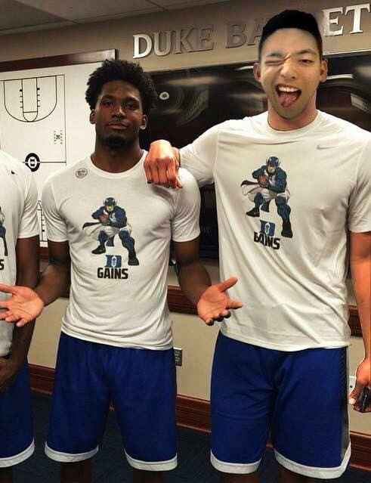
Jerry Li
Duke

“Right now I'm studying computer science and thinking about. I think the research program really taught me how to gather resources and connect different sources with each other and it's helped me on a lot of research essays. Right now I'm focused on a start-up company that specializes in bus chartering: Letskedaddle.com.”

Brian Rogofsky
University of Pennsylvania – Wharton – concentrating in Finance, Statistics, and Marketing

The research program … had a profound influence on me, especially in choosing what to concentrate in…. The statistics as well as just learning how to best analyze a question or problem and then designing surveys and experiments to come to meaningful insights has been invaluable and gives me a leg up in a lot of areas. I literally use that knowledge every day.

Barry Yang
Dartmouth

Right now I'm studying computer science and government. I'm doing a research
project with a local professor on perceptions of elections in Japan. Along with SPSS I've also learned how to use Stata and R. Research has definitely helped me in college because I had an advantage over my classmates in many of my relevant classes. I also think research helped define some of the things I was interested in college.

Class of 2013

Arshia Aalami
Columbia University, majoring in biomedical engineering

I am currently working with Dr. Ruth Fischbach in analyzing data related to hurtful words said to children with autism and how parents cope with hearing this negative information.

Ethan Levine
Duke University, planning to major in math and possibly statistics

I am currently doing research in which I am using wavelets to model paintings in order to detect and fix cracks and missing portions, as well as to digitally refurbish or age paintings.
Doing research was probably the most important thing I did in high school. It taught me many ideas and concepts that I would use and apply, and it gave me a new way of approaching problems and looking at the world.

Paul Rogofsky
University of Pennsynvania

Paul is concentrating in Finance at Wharton and Math in the College of Arts and Sciences as well as minoring in Computer Science.

Alain Sherman
Northwestern University, Honors Program in Medical Education,
Psychology Major, French Minor, Global Health Studies Minor
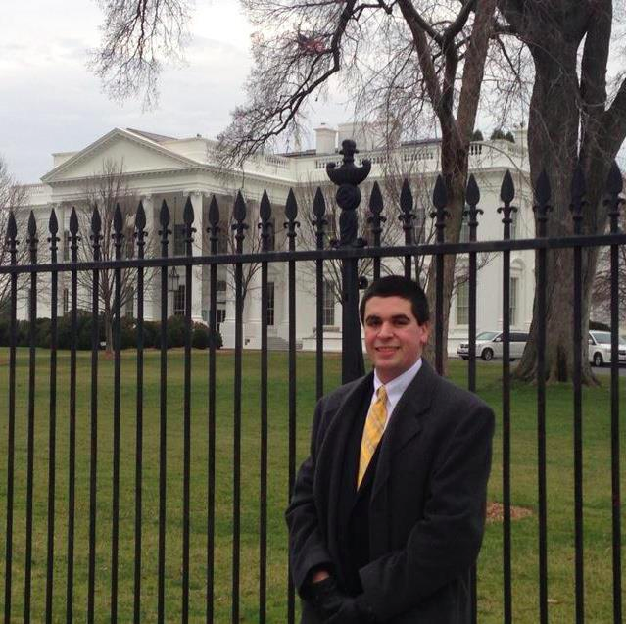
On campus, Alain is actively involved in Northwestern's Model UN club, serving on the dais staff of the Arctic Council and the Special Political and Decolonization Committee (SPECPOL). This summer he will be studying sociology and art history in Arles, France and will likely be working in a developmental psychology lab in the fall. In the future, he hopes to participate in Northwestern's public health program in Tel Aviv, Paris, or Sydney. After college, Alain will matriculate to the Feinberg School of Medicine to pursue a career as a physician.

The independent research program at RHS prepares you for life after high school in ways you can't even imagine. It opens door to numerous opportunities and gives you a firm background for whatever field you choose to pursue. For example, this year I took a Research Methods class as part of my psychology major. The content of the course was identical to what I learned in Roslyn, and I was at a major advantage being the only student who knew how to analyze data with SPSS. Even our textbook was the same Cozby text that we used in high school research seminar!

Alexander Wu
Columbia University

I graduated from Roslyn in 2012 and just finished college at Columbia last year. I’m currently in grad school at Harvard studying computational biology/bioinformatics as a part of a 2-year masters program. I’m thinking about possibly going for a PhD in a similar field and will most likely be applying for that sometime later this year.

Class of 2012

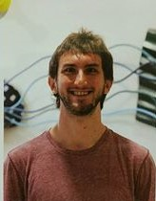
Michael Cervia
University of Chicago

I finished my Physics BA and Math BS at UChicago last spring, where I spent about three years working in an experimental atomic physics research group (Simon Lab). I'm finishing up my first year of the UW-Madison Physics PhD program, taking graduate courses in math and physics and teaching introductory physics courses, but I'm about to transition towards research this summer, likely in a theory research group studying quantum information.

While the techniques in studying physics have little apparently in common with the social and medical sciences research I had the pleasure of participating in during my time in Dr. Weseley's program, I certainly found that the professional and rigorous reasoning skills I was encouraged to learn have been valuable in my work since graduation.

Joanna Finkelstein
Pomona College, majoring in Computer Science and minoring in Psychology

I'm doing research in Human Computer Interaction for the summer and really enjoy it. I wrote an op-ed about cyberbullying and bystander intervention for my Social Psychology class that was published in the Huffinton Post Teen Blog. Recently, I received an email asking permission to reprint the article in a textbook titled Introducing Issues with Opposing Viewpoints: Cyberbullying by Cengage Learning. The article can be found at this link:
http://www.huffingtonpost.com/joanna-finkelstein/whose-responsibility-is-it-anyway_b_4391963.html

Daniel Sikavi
Harvard Medical School, 2020
Princeton University, AB in Ecology and Evolutionary Biology, Certificate in Global Health and Health Policy, 2016

Daniel is currently a medical student at Harvard Medical School. He is a recent graduate of Princeton University, where he studied Ecology and Evolutionary Biology and obtained a certificate in Global Health and Health Policy. At Princeton, his academic work focused largely on global health. He conducted research on the management of portal hypertension in children involved in a liver transplant program in Marseille, France. He also spent time analyzing the dynamics of diarrheal disease and helminth co-infection in Ho Chi Minh City, Vietnam. You can find a list of his published research at http://bit.ly/2nbyjaI. He credits the RHS research program with sparking his interest in research as a means to improve human health. The program additionally strengthened his work ethic, writing skills, analytic abilities, and scientific curiosity.
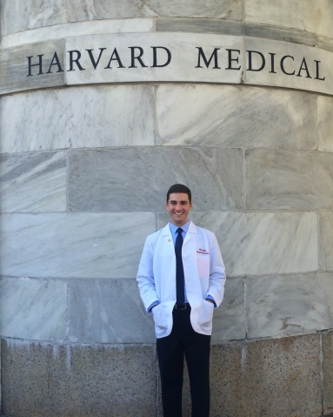

Participating in the research program was definitely the best decision I made during my time at RHS. The program greatly helped in my adjustment to academic life in college and provided me with the confidence to succeed both inside and outside the classroom. My writing skills, analytical abilities, and worth ethic greatly benefited from conducting independent research in high school, and my research experiences gave me a leg up in obtaining competitive summer internships and work opportunities.

Brian Suh
Vanderbilt University, Computer Science and Economics Major

Brian is currently the manager for the Vanderbilt Commodores Men's Basketball team. He also participates in VSVS (Vanderbilt Students Volunteers for Science) where he goes with a group of other Vanderbilt students to teach inner city middle school students lessons in science. Brian also volunteers at the Martha O'Bryant Center food bank.
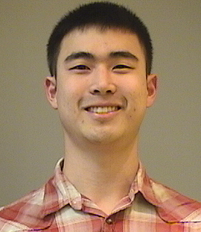
Research taught me the values of hard work and never giving up. Although there were many tough setbacks in my projects, Dr. Weseley showed me that I should never give up. Research also taught me how to speak better in public and it helped me strive outside of my comfort zone.

Alex Wu
Columbia University, 2016

I’m currently in grad school at Harvard studying computational biology/bioinformatics as a part of a 2-year masters program. I’m thinking about possibly going for a PhD in a similar field and will most likely be applying for that sometime later this year.

Class of 2011

Hilary Hofer
Cornell University, Major Undecided

All of the things that I learned by doing research at Roslyn have really helped me later on in life. Not only have research concepts such as statistics and how to run experiments come up several times in college, but the hard work, dedication, and countless hours spent doing research resulted in me being better prepared for college and life in general.

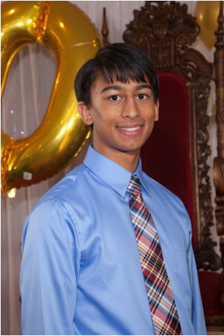
Arjun Kumar
Stony Brook University, Scholars for Dental Medicine Program, Psychology Major, Biology Minor

In terms of extracurricular activitiess at SBU, Arjun is a part of an Indian fusion a cappella team called Yuva and is the secretary for the team. He is also involved in his dorm's, Toscanini College Hall Council and will be the treasurer next year.

Research in high school was a very important experience. It made me realize how important it is to get things done before deadline. It also advanced my curiosity by always making me ask more questions ... and definitely made me a better writer as well because of all the essays and papers that were assigned and edited repeatedly.

Kamyar Noori
Boston College, Economics Major

My experience in the research program has prepared me for college better than any other class I took at Roslyn. From analyzing information critically to writing [good] papers to presenting in front of others, the skills I developed conducting research have been transferable to all aspects of academic life at college. Even if you don't do research after high school, the skills you learn through the research program will prove to be invaluable regardless of the field you choose to pursue.

Sarah Pak, Princeton University 2015
Princeton University, Woodrow Wilson School, Certificate in East Asian Studies
At Princeton, Sarah was involved with the fencing team, worded as a Research Assistant with Ben Hutchinson in memory and attention (http://www.princeton.edu/ntblab/people. xml), was in an a cappella group, and was a writer for AFP (American Foreign Policy). Her thesis was a psychology study on data visualization which she hopes to publish. She was also the President of Colonial Club, one of Princeton’s eating clubs of which Dr. Weseley was a member for one semester.
After graduating from Princeton, Sarah completed a year as a Princeton in Asia (PiA) fellow in Chiang Mai, Thailand. As of June, 2016, she was starting work as a federal consultant at Deloitte in DC.
My research experience at Roslyn has continued to help me in many ways. The work ethic and discipline that research in high school required prepared me well for the rigors of college. I'm still working in a lab here at Princeton, and I recently got back from VSS, a neuroscience conference in Florida, where my postdoc presented a poster (on which I'm listed as second author). I'm very grateful to Dr. Weseley and the Roslyn research program for opening me up to the wide world of academic research.

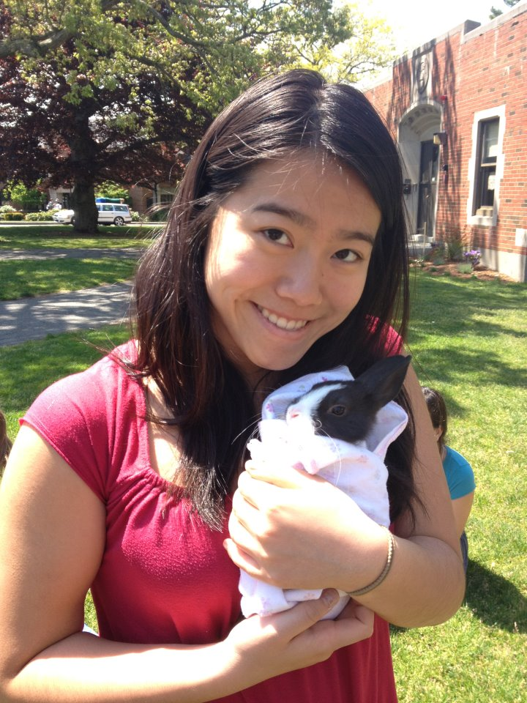
Faye Sun
Boston College, Major Undecided

One acquires an unbreakable perseverance through the high school research program from acquiring information, fact-checking, writing that research paper, applying to competitions, etc. While research is not currently a part of her life at Boston College, being part of Dr. Weseley's program gave Faye a set of tools that made her a more skilled presenter and a more thorough student, resulting in better quality work that has made her stand out at Boston College. After having to put herself out there to obtain a mentor for research, Faye has become unafraid to continue to reach out to professors in college and apply to various programs. This has opened doors to many opportunities, from service trips to New Orleans, to exclusive CEO club lunches, to obtaining positions in several clubs.

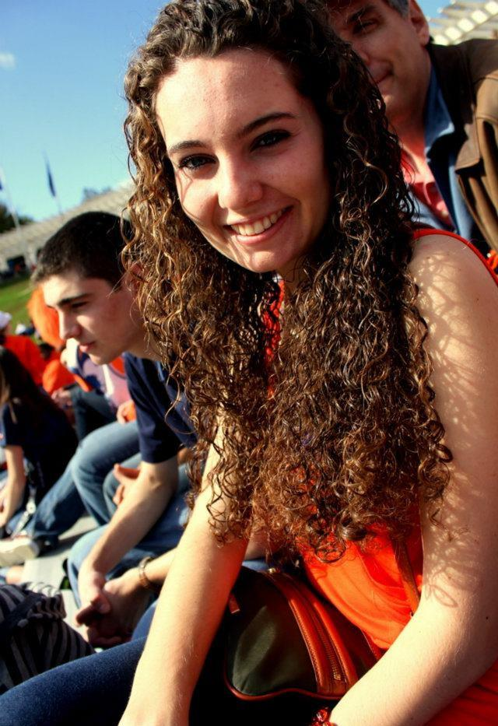
Caroline Trezza
University of Virginia, Anticipated Economics Major

I feel very fortunate to have been a part of Roslyn’s research program. The analytical skills that it helped foster and the time, effort, independence, and resilience that it required have proven useful in any and all subjects; the experience it gave me has always been helpful when speaking to faculty about opportunities outside of the classroom. My involvement in research was probably the most important factor in shaping me as a student.

Class of 2010

Taha Adib
Dartmouth College, Anticipated Economics and/or Sociology Major

Research definitely pushes you, and it might drive you crazy at times, but you will come to appreciate the strong work ethic, maturity, and skills you gained from it. Your research experience definitely gives you a leg up when it comes to applying for science/research-internships on-campus -- you already know the scientific method, have written a full fledged paper, and you know all the other logistical and organizational tactics. Meanwhile, most students who are applying do not have research experience - their high schools didn't offer any program of the sort.

Austin Blau
Tufts University, 2014

I am currently working in GE Capital as part of the Risk Management Program

Josh Freeberg
Cornell University, BS in Information Science; Computer Science, Game Design, and Communications minors, 2014

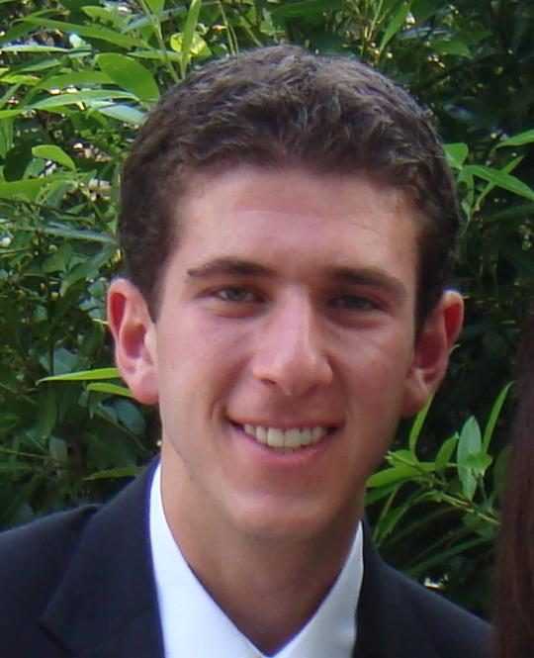
This summer I'll be interning in San Francisco at Cisco Meraki, a division of Cisco that deals mainly with cloud-based computer networking. After that I'll be returning to Cornell for one more semester to finish a Master of Engineering in Computer Science.
In college the statistical tests and processes Dr. Weseley taught us and the implementation of how to write a paper have helped me a lot. In biology lab had to make a poster and the methods we used are almost identical.

Zachary Goldsmith
University of Pennsylvania, Chemistry and Mathematics, 2014
Currently: PhD student, physical chemistry, University of Illinois at Urbana-Champaign
http://hammes-schiffer-group.org/zachary-kall-goldsmith/
Gaining research experience in high school made the transition to college much easier. My experience helped me hone my interests and find a research position in the field in which I wanted to work rather quickly.

Zach is currently working in the fields of theoretical and physical chemistry under Dr. Andrew Rappe. He is studying the phenomenon of "intelligent catalysis" using quantum mechanics and thermodynamic computational techniques.

Samantha Halpern
Princeton, Chemical & Biological Engineering, 2014

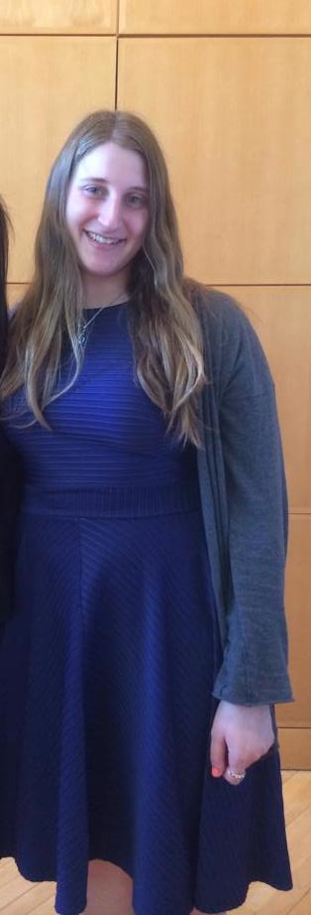
I spent the past 3 years working in a tissue morphodynamics laboratory and just finished my senior thesis. For the past two summers I have worked at Imclone, a subsidiary of Eli Lilly, working on the development of new cancer drugs. I am graduating with a degree in chemical & biological engineering. Next year I will be working as a consultant at IBM. I will specifically be working on cases related to pharmaceuticals and chemical/biological engineering.
A lot of work I did for high school research has helped me in college. When I interviewed to ginto my lab on campus and for my summer job at Eli Lilly, I spent most of my interview discussing my projects from high school.

Sam has spent the past 2 semesters working in a tissue morphology lab on campus and plans to spend the next 2 years in this lab. This summer, she will be researching cancer pharmaceuticals at ImClone (a subset of Eli Lilly).

Anouva Kalra-Lall
Case Western Reserve University PPSP, Biochemistry major

Looking back, I realize that I am not only lucky to have had the opportunity to research (especially because not all high schools across the nation even have research programs) but also to have learned the components of different types of research in a structured way through having the Roslyn research sequence.

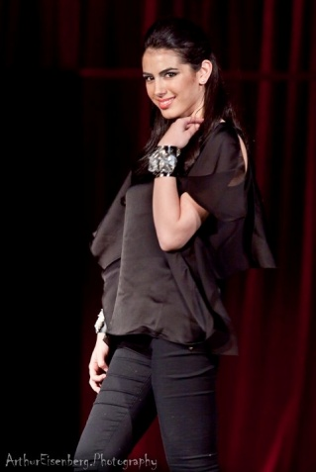
Sharona Khaneyan
New York University, Spanish and Linguistics major with a minor in Chemistry

I truly believe that the research experience in high school prepares you for the research experience in college. The whole experience of finding a mentor, working with that professor, and actually conducting research is the exact same process I am encountering now in college. Having had this previous experience, I feel that I am at an advantage ... because I was prepared so well in the high school's research program.

Lauren Kobrick
University of Michigan, Public Policy, 2014

Being a part of Roslyn High School's research department under Dr. Weseley gave me confidence to speak in front of an audience, a respect for the amount of time/effort/energy it takes to put together a high quality research project and an appreciation for the importance that research plays in everyday life.

My most recent research project was titled "Positivity Bias and White Prejudice in Elections with Black Candidates" (abstract below). I was the team leader of the project in the Political Science Department at the University of Michigan. In 2014, I am starting law school at Benjamin N. Cardozo School of Law in NYC.
In the last presidential election, Barak Obama was the first African American to be elected President of the United States of America. This study seeks to determine the social desirability pressures constituents face when voting for an African American candidate verse a White candidate in order to appear non-racist. There were three survey conditions given to adults raging from ages 18-50. One question varied on each condition about President Obama to test social desirability factors. The first condition was the control condition – a simple fact was stated about President Obama that all participants will agree with. The second condition tested increasing a specific set of social desirability pressures to appear non-racist – if people say something bad about President Obama (an African American), they will be more likely to vote for an African American candidate in the future to appear non-racist. The third condition decreases social desirability pressures to appear non-racist – if people say something good about President Obama, they will be more likely to vote for a white candidate in the future because they already proved they are not racist.

Ariel Lefland
Tufts University, Biopsychology major with a possible double major or minor in Biotechnology, 2014

Research at Roslyn was a challenging and rigorous program ... and one of the most memorable intellectual experiences I had during high school. Looking back, I can see that the research program helped me think critically and be a motivated student.

Aaron Levine
Northwestern University, Political Science and History, Class of 2014
Yale Law School, Class of 2017

The research program definitely gave me the ability to start and finish a project independently. And, of course, I learned so much about the research process from how to read literature to analyzing data.

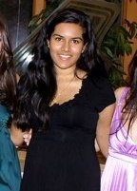
Geetika Rudra
Columbia University, Creative Writing and American Studies, 2014

In January 2015 I left my job at ABC News and founded String Machine, a software company that builds and tests tools designed to make reporters newsrooms more efficient. Our first product is a service that can algorithmically detect alterations and manipulations to pieces of photojournalism. I am also a fellow at Columbia University's Brown Institute for Media Innovation. Through the Brown Institute I received a seed investment to build a platform that uses machine learning methods to analyze qualitative data. Our first application of this platform is a project called Urgent Care Review, which seeks to analyze online patient reviews of New York City's urgent care centers to generate report cards for each clinic. Despite my foray into tech and entrepreneurship, I'm sticking to my roots as a journalist and working on my first book, a narrative history of South Asian immigration to the United States that explores the process of how Indians, Pakistanis, and Bangladeshis become "white." In May I will graduate from Columbia University's Graduate School of Journalism with a masters in (perhaps obviously) journalism. You can get a more complete picture of work on my site, geetikarudra.com

As a journalist and developer, I've found that the skills I learned in RHS research have found their way into almost every aspect of my career (I was a Creative Writing and American Studies major as an undergrad at Columbia, so early on RHS research was the only background I had in anything data related.) Understanding different types of data and the corresponding analytics helped me transition from journalism into computer science to start my company. Although I conducted research in the behavioral sciences in high school, research in computer science is quite similar. I use many of the same scientific methods today when building and testing newsroom products. These methods have also made me a better researcher for my book. When working on my book proposal I quickly found that teaching myself the pre-existing discourse surrounding my book topic is quite like conducting a comprehensive literature review.

Kevin Xu
Columbia University, 2014

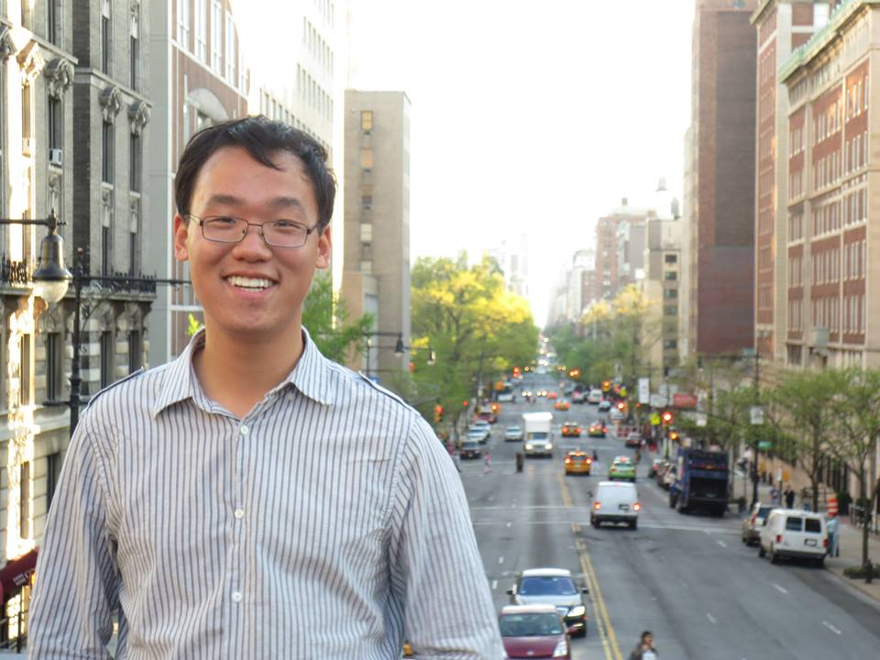
Roslyn’s research program was one of the most rigorous, intellectually stimulating, and worthwhile experiences I have ever had. Doing research in high school challenged me and gave me an opportunity to apply what I learned in the classroom to the world around me. It made a more critical thinker and inspired me to pursue a career in science.

Kevin Xu is a medical student at the Icahn School of Medicine at Mount Sinai. In college, he studied biology and anthropology at Columbia University, where he graduated summa cum laude, was elected to Phi Beta Kappa, and served as Editor-in-Chief of Columbia's student-run Journal of Global Health. Kevin's research interests focus on the molecular epidemiology and social determinants underlying cancer incidence in urban communities, particularly in New York City. A recent review article he authored can be found at http://www.biomarkerres.org/content/3/1/5.
He credits his time with Dr. Weseley for not only helping him develop a robust work ethic but also for sparking his career interests in becoming a cancer epidemiologist.

Class of 2009

Rachel Bass
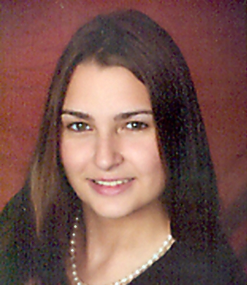
Vanderbilt University, Special Education (High-Incidence Disabilities) and Cognitive Studies

The independent research program ... has proven to be the most useful and worthwhile experience from high school. The hard work pays off!

Rachel is currently working for the Office of Housing and Residential Education at Vanderbilt University as a Head Resident Advisor for first-year students. Also, she is the President of Alpha Phi Omega, a co-ed service fraternity on campus.

This summer she will be interning with Teach for America as an Operations Coordinator for the Institute Management Team in New York. Rachel will be graduating early in December 2012 and is planning to get a Master's degree in Education Policy.

Matt Glickman
University of Southern California, Marshall School of Business, USC School of Cinematic Arts
Majoring in BCA (business and cinematic arts)

Looking back, the research program most definitely gave me the work ethic needed to succeed in college. The challenges I faced while in the research program prepared me (much more than ANY class I took in high school, well maybe psych) to face the challenges I currently see every day in college.

As a board member of the Inter Fraternity Council (the group that governs the Greek System) Matt has utilized research skills, like proper sample size and randomness, to gauge Greek students’ feedback on many university issues.

Samuel Vitello
Bowdoin College, 2013

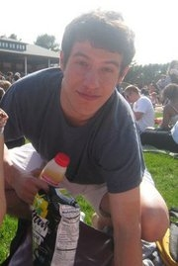
Sam graduated from Bowdoin College in 2013 with a double major in Government and Economics and a minor in English. While in college, Sam assisted with urban studies research at various institutions including NYU’s Wagner School of Public Service and the Brookings Institution’s Metropolitan Policy Program. He also completed an independent study during his junior year in which he looked at the Community Reinvestment Act of 1977 to see if the legislation was precipitating demographic change in low- income urban communities. The resulting paper is now forthcoming in the economics journal Housing Policy Debate.

Class of 2008

Lisa Cervia
Boston University, College of Engineering (Biomedical Engineering), 2012
Duke University, Masters in Biomedical Engineering, 2014

Lisa investigates how networks of neurons interact to subserve functions such as learning. She created an improved experiment chamber to control the temperature of the nutrient bath, and make it possible to image different sections of the nerve bundle using SolidWorks. She investigated the effects of different toxins on the physiology responsible for producing the optical signal associated with action potential propagation in order to better understand the biology as well as to optimize the imaging system. Lisa created movies of action potential propagation by searching for an optimum configuration of optics to make a line image of the nerve bundle onto a high-speed linear array. Programming was needed to interface between linear array and the data acquisition system. She was accepted for oral presentation at Biomedical Engineering Society (BMES) 2009 annual meeting.

Publications:
Cervia, L. D., McGowan, J. P. and Weseley, A. J. (2010), Clinical and Demographic Variables Related to Pain in HIV-Infected Individuals Treated with Effective, Combination Antiretroviral Therapy (cART). Pain Medicine, 11: 498–503. doi: 10.1111/j.1526-4637.2010.00802.x
Cervia, L.D. McGowan, J. Weseley, A., et al. “Clinical and Demographic Variables Related to Pain in HIV-Infected Individuals Treated with Effective, Combination Antiretroviral Therapy (cART).” American Federation for Medical Research 2008 Eastern Regional Meeting. (Abstract). Poster Symposium Presentation. April 9, 2008. Washington, D.C. Abstract #430777. Publication In: Journal of Investigative Medicine. 2008. 56(5):815. Abstract #P10.
K. Schoener, L. Cervia, and I. Bigio, "Novel Cooled Sliding Chamber Elucidates Origins of Action Potential Modulated Birefringence," in Biomedical Optics, OSA Technical Digest (CD) (Optical Society of America, 2010), paper BTuD80.

Jenna Kahn
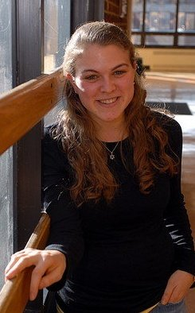
Brown University, Psychology/Pre-med

Being part of the independent research program at RHS was one of my favorite things about high school. I acquired skills through the program that have tremendously helped me in college- such as improved public speaking and writing abilities and knowledge of SPSS.

Jenna has just completed her honors thesis concerning personality psychology. She will be starting medical school at the Warren Alpert Medical School during the fall of 2012.

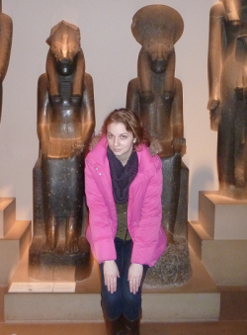
Brittany Katz
Brown University, Human Biology: Human Health and Disease

Brittany is planning to start a research project involving the reproductive choices of HIV positive women in under-served communities.
She will then be starting medical school at The Warren Alpert Medical School of Brown University.

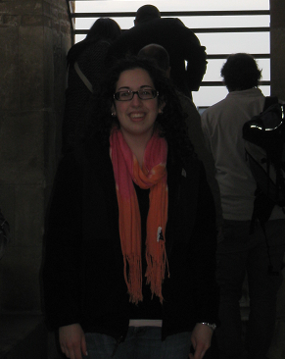
Samantha Lefland
Cornell University, Policy Analysis and Management

Samantha worked as a research assistant in the sociology department where she is helping with a project on gender and academic mobility

Class of 2007

Samantha Goldstein
Lehigh University, Behavioral Neuroscience major, animal behavior research

After college I went to New York College of Osteopathic Medicine and I am currently in my second year of internal medicine residency in NYC. Since graduating high school, I have been involved in research from diabetics undergoing CABG to corneal epithelial wound healing to case reports on breast cancer and pericarditis. My current research involves quality improvement projects aimed at making my hospital more efficient.

“I will never forget the positive response I received after a presentation I gave my first semester of college. My professor was so impressed with my knowledge of statistics, and I attribute that all to my time with Dr. Weseley.”

Erika Kolb
Cornell University, 2011

I am currently living in London working as an associate in the structured finance team at the law firm Reed Smith.

Jessica Nussbaum
Cornell University, 2011

I work for Google as a Global Strategy & Commercialization lead for DoubleClick. I'm also studying part-time at NYU Stern School of Business to get an MBA, graduating in May 2018. Doing research definitely helped shape my analytical and organizational skills, which I still use today.

Michael Shores
Cornell University, Policy Analysis & Management, 2010
Michael's interest in data analytics started in Roslyn's research program and has carried throughout his professional career. He graduated from Cornell University in 2010 with a B.S. in Policy Analysis and Management, where he wrote a thesis on the impact of social networks on white collar crime. Since graduating, Michael has worked in both public and private sector data analytics groups. He is currently the Senior Manager of Machine Learning at United Airlines. Michael is also concurrently pursuing his Masters in Analytics at the University of Chicago.
Doing behavioral science research was a great spring board for recognizing my academic interests and getting involved in research at college. The writing, statistical and SPSS skills I learned in high school made me a much more competitive applicant for research assistant positions and were relevant to several classes. Use your time in the program to find a topic that truly interests you!

Class of 2006

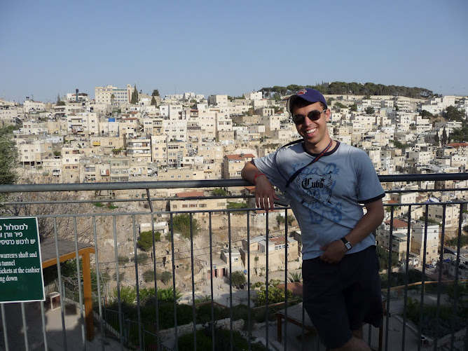
Andrew Forrest
Williams Class of 2010, University of Cambridge Class of 2011

Andrew graduated RHS in 2006, then Williams College in 2010 with a B.A. in Political Economy, and then University of Cambridge in 2011 with a M.Phil in Politics. After completing my masters in the UK (where he wrote a thesis comparing the campaign finance and lobbying regulatory systems of the US and UK), he returned home to work for MoveOn.org on their media team. In January 2012, Andrew left MoveOn to join a new startup called Upworthy (www.upworthy.com), which focuses on spreading important, meaningful content on the web. Generally, they’re a progressive site looking to make important issues as fun to share as kitten videos. He’s put his research skills to good use at Upworthy, where he focuses on analysis and optimization, conducting experiments to help us improve our understanding of what makes content go viral.

Michael Hofer
Cornell University Class of 2010, Columbia Law School

Michael wrote an Honors thesis in college on the effect of the 1998 Master Settlement Agreement on cigarette advertising. The MSA introduced a plethora of new regulations on the aforementioned advertisements and shortly afterwards, the number of cigarette advertisements in magazines became almost nonexistent. Michael’s study aimed to determine whether the MSA was the reason for the above change or merely a coincidence.

Michael is currently a real estate associate at Fried, Frank, Harris, Shriver & Jacobson LLP. He works on sales, acquisitions, leasing and financing (from both the borrower and lender side) for commercial properties in New York and elsewhere across the United States.
My research background helped prepare to think analytically which helped not only in college and law school but also as a valuable way to approach the problems and situations that my clients deal with over the course of a transaction.

Paulene Meyers
Stanford University Class of 2010

Paulene graduated from Stanford with a major in Political Science with a focus on Education Policy. She wrote her senior honors thesis on the effects of Race to the Top, a national education grant program. After teaching for 3 years at Uncommon Schools, a charter management organization operating throughout the tri-state area, she earned a Masters in Public Policy from the Kennedy School of Government at Harvard and is now working as a Product Owner at the Relay Graduate School of Education.

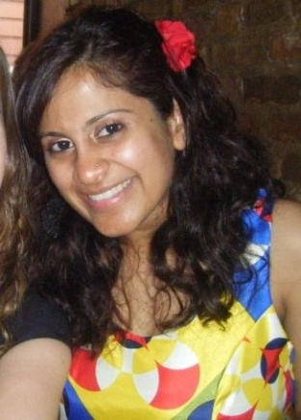
Class of 2005

Alafia Akhtar
Stony Brook University

While at Stony Brook, Alafia was in a five year combined BA/MBA program where she majored in Art History and Criticism and received her masters in Business Administration. In Alafia’s final year of school she began working at the Solomon R. Guggenheim Museum as the assistant to the Operations Manager, where she is currently employed. Working at the Guggenheim Museum has allowed Alafia to combine her love of art and business and allowed her to appreciate a historically landmarked property and realize her passion for historic preservation. She will begin a masters program in Historic Preservation at Columbia University in Fall, 2011.
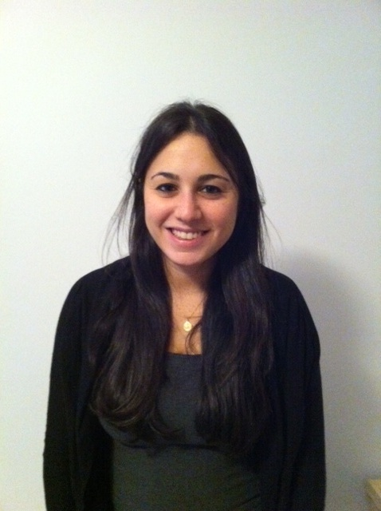
Jessica Cohen
Columbia University, 2009

As an undergrad, I studied history and wrote for Columbia's literary magazine. I also worked at the New Yorker magazine in varying capacities and at the Charlie Rose Show on PBS. I'm currently a student Columbia Law School, and I'm to graduate this month. As of September, I'll be working as a litigator at a law firm in New York City.
It would be easy to understate how formative Dr. Weseley's program was for me. Learning research methods, statistics, and organizational skills (!) has influenced not only my academic work (even the law), but also the way I think and express myself.

Class of 2004

Michael Sloyer
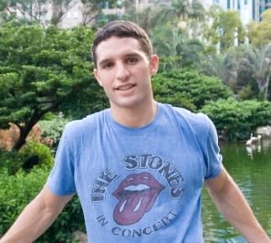
Duke University, 2008

Michael is currently an equity index volatility trader at Goldman Sachs. After working four years in New York trading US indices, he is now moving to the Hong Kong office to trade options on China, Korea, and Australia. He is an avid photographer and sells his work through his website and in street fairs. Link to website: http://michaelsloyer.com/

Class of 2003

Zach Galin
Northwestern University, BS in Learning and Organizational Change, Class of 2007
Zach is currently an Education Consultant for the State of Wisconsin and is the owner of Galin Education. In his role in state government, Zach oversees private post-secondary schools that operate both physically and online in Wisconsin. His agency gathers outcomes data from over 170 institutions and analyzes the aggregate data to provide recommendations to schools for improvement.

In 2010, Zach founded Galin Education (www.galined.com), a business that provides education services for children, families, and organizations (from college admissions consulting to afterschool program development).
While at Northwestern, Zach conducted a variety of behavioral research studies to study how and why organizations become more effective. Zach was then accepted into Teach for America and taught science, test-taking strategies, and organizational skills in a middle/high school in the South Bronx. While a corps member, he received his masters degree in education from the Bank Street College of Education. His thesis, Tardiness in Under-served Schools, involved both quantitative and qualitative research methods.

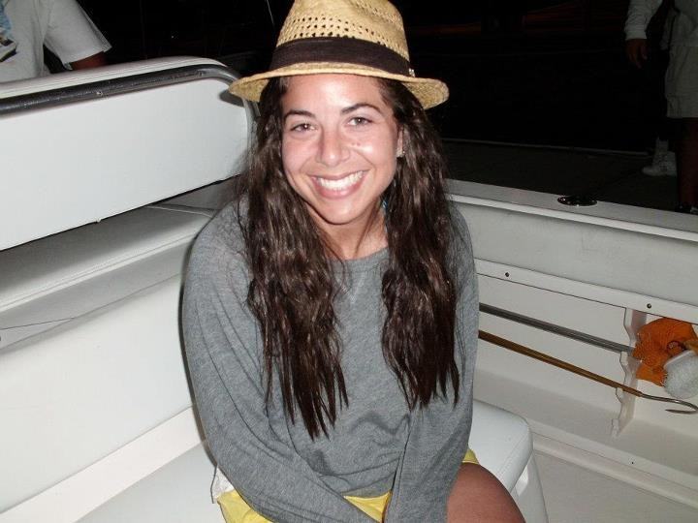
Class of 2002

Allison Deutch (formerly Pinchasick)
BS, Cornell University, College of Human Ecology, 2006
MD, SUNY Buffalo School of Medicine and Biomedical Sciences, 2010
Adult Psychiatry Residency, NYU School of Medicine, 2014
Psychosomatic Medicine Fellowship, NYU School of Medicine, 2015

Allison attended Cornell University where she majored in Biology and Society, a joint major between The College of Arts & Sciences, The College of Human Ecology, and The College of Agriculture & Life Sciences. Allison went on to earn her Medical Degree from SUNY Buffalo School of Medicine & Biomedical Sciences and completed her Psychiatry Residency at NYU School of Medicine. Allison was also a member of the Psychosomatic Medicine 2014-2015 Fellowship class & is currently working as an Attending Psychiatrist on the Consultation-Liaison Service at Tisch Hospital, NYU Langone Medical Center. Her major areas of interest include the development of psychopathology in women with adverse obstetrical outcomes including recurrent perinatal loss, stillbirth, critically ill neonates, etc. Another major area of interest is the evolution of the “Breast Is Best” movement, and the extent to which this cultural phenomenon impacts the development of mood and anxiety disorders in the perinatal and post-partum period.

“Research has been an incredibly integral part of my personal and professional development. It has greatly enriched my clinical work and I am thrilled to have the opportunity to work in an environment where my intellectual curiosity is continuously fostered. I am so grateful to Roslyn High School and Dr. Weseley for starting me on this amazing journey.”

Christopher Repole
Cornell Class of 2006, Brooklyn Law Class of 2011

My time in the RHS research program was excellent training in the research skills and analytical reasoning required of me every day in law school and, now, in law practice.

At Brooklyn Law Chris was an Editor of the Journal of Corporate, Financial & Commercial Law, and where he was also Moot Court Honor Society Vice President. Furthermore, he led a clinic advising technology, entertainment and media company clients on corporate, labor and intellectual property law issues. Now, he is part of the staff counsel at the Screen Actors Guild (now known as SAG-AFTRA), where he reports to the General Counsel, addressing any and all legal issues facing the organization. Recently, he led the SAG-AFTRA team crafting their policy on Federal Communications Commission (FCC) regulations. In that capacity, he drafted the SAG-AFTRA policy statements filed with the FCC.

Adam Stern
Brown University Class of 2006, SUNY Upstate Medical University MD Class of 2010, Harvard Longwood Psychiatry Residency Program Class of 2014

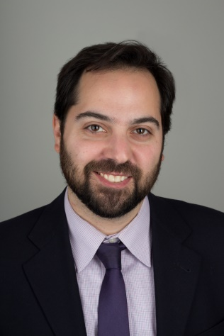
Adam is an Instructor in Psychiatry at Harvard Medical School. He works as the Director of Psychiatric Applications at the Berenson-Allen Center for Noninvasive Brain Stimulation where he specializes in administering and researching transcranial magnetic stimulation for patients with treatment-resistant depression. Since Adam’s time at RHS, he has also continued to write creatively and has attempted to combine his interests in the humanities and science by working on creative non-fiction that focuses on the medical humanities. His 2016 novel, Break, examines the world of medicine and psychiatry through the lens of a medical student experiencing a psychotic break.

To this day, the skills I learned doing research projects at RHS continue to provide the foundation for my scholarly work.

Selected links to published work:
- http://www.sciencedirect.com/science?_ob=ArticleURL&_udi=B6WCV-4SWP248-1&_user=10&_coverDate=12%2F31%2F2008&_rdoc=1&_fmt=high&_orig=gateway&_origin=gateway&_sort=d&_docanchor=&view=c&_searchStrId=1696538110&_rerunOrigin=google&_acct=C000050221&_version=1&_urlVersion=0&_userid=10&md5=a8b3da68f44ca5b641ec6ae34206294b&searchtype=a
- http://ajp.psychiatryonline.org/cgi/content/full/167/3/353
- http://ajp.psychiatryonline.org/cgi/data/167/12/A30/DC2/1
- http://pulsemagazine.org/Archive_Index.cfm?content_id=105
- http://www.upstate.edu/bioethics/thehealingmuse/09_muse/09_stern_andthensomething.php

Class of 2001

Allison Liebhaber
Brown University Class of 2005

I believe research helped me greatly in my career path ... My experience from the research program at Roslyn High School allowed me to get a job as a research assistant and also gave me the skills I needed to succeed in that position, which opened up many opportunities for me upon graduation.

For four years after graduating college, Allison worked as a Research Analyst at the Center for Studying Health System Change (HSC) in Washington, DC. HSC is a nonpartisan organization that conducts health policy research and analysis focused on the U.S. health care system to inform the thinking and decisions of policy makers in government and private industry. While there, Allison coauthored 13 publications on a variety of topics. Currently, Allison is earning a Master of Public Health degree from the Harvard School of Public Health. After graduation, she will start a position at Memorial Sloan Kettering Cancer Center in the Department of Regulatory Affairs.

Link to list of publications: http://www.hschange.org/index.cgi?func=search&s_auth=au198
Class of 2000

Aaron Halegua
Brown University, 2004

Aaron is a lawyer and a researcher at NYU Law School, where he studies labor law, legal aid, and other issues in both the US and China. He also consults for law firms, companies, and non-profits, primarily on labor issues in China. Prior to this position, Aaron clerked for a federal district court judge in Manhattan and was a Skadden Fellow at the Legal Aid Society in New York City, where he represented Chinese immigrant workers in labor matters. He has a J.D. from Harvard Law School and B.A. from Brown University. The understanding of social science methodology that he gained at RHS has been useful in guiding his research on the Chinese dispute resolution and legal systems, about which he has published several articles. More information is available at his website: aaronhalegua.com.

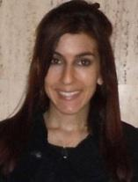
Class of 1999

Tara Maller
Dartmouth College, 2003

Tara is a Ph.D. candidate in the Department of Political Science at MIT and a member of MIT's Security Studies Program. Her dissertation develops and tests a new theory of the effectiveness of sanctions by assessing the role of information, communication, and diplomatic ties as determinants of sanction outcomes. Whereas previous studies of sanctions tend to focus on economic sanctions, her project aims to develop a more nuanced understanding of sanctions' success and failure through an analysis of both economic and diplomatic sanctions. She has published articles in Studies in Conflict and Terrorism ("The Dangers of Diplomatic Disengagement in Counterterrorism") and The Washington Quarterly.

Prior to MIT, from 2004–2006, Tara worked as a military analyst at the Central Intelligence Agency, focusing on the Iraq insurgency. Tara also served as an intern in the Senate office of Senator Hillary Rodham Clinton and at Dartmouth's Institute for Security Technology Studies. Tara holds an M.A. in International Relations from the University of Chicago and a B.A. in Government from Dartmouth College. She has also studied politics as a visiting student at Keble College, Oxford University.
Link: http://belfercenter.ksg.harvard.edu/experts/2227/tara_maller.html

Erica Stechel Langer
Washington University, 2003

Erica is a third year student in the Clinical Psychology PsyD program at C.W. Post/Long Island University. As part of the 5-year doctoral program, she is required to complete coursework, a dissertation and clinical training in a number of settings, including outpatient clinics and hospitals. Prior to graduate school, Erica worked as a Research Study Assistant at
Memorial Sloan-Kettering Cancer Center (MSKCC). As part of her position, she recruited patients for research studies, collected and managed data, and assisted with new protocol development and review. Erica learned a lot about cancer care and working with medically ill patients while working at MSKCC. Although her graduate program is clinically focused, it has been very helpful to have a research background.

Link to her program's website:
http://www.liu.edu/CWPost/Academics/Schools/CLAS/Dept/Psychology/PsyD2.aspx

Note: To add your bio, update your information or just say hi,
please email aweseley@roslynschools.org

